# Media Analysis - Will ChatGPT and AI have an impact on Saudi workforce productivity_ _ Arab News

## Short Summary

The article is about how artificial intelligence technologies like ChatGPT could enhance Saudi Arabia s workforce productivity by boosting economic development, alleviating job loss fears through skill enhancement, increasing efficiency, and impacting various sectors such as healthcare, transportation, energy, finance, and retail, while requiring a strategic approach to integrate AI into operations effectively.

## Summary

- AI technologies like ChatGPT can enhance Saudi Arabia's workforce productivity by automating mundane tasks and enabling strategic focus. This fosters economic development through increased efficiency and innovation.  
   
- Concerns exist about job displacement due to AI; however, 50% of employees believe it boosts productivity while 51% see potential for better positions. Embracing AI involves cultivating a strong culture of learning and adaptation.  
  
- Raymond Khoury highlights AI's positive impacts across sectors such as healthcare, transportation, finance, and retail by optimizing operations and fostering innovation. However, the automation of tasks could threaten job stability unless employees upskill.  
  
- Implementing AI in Saudi companies requires a strategic approach that defines objectives, addresses bottlenecks, and selects appropriate technologies while fostering an environment conducive to learning and agility for successful integration.

## Question 1

The text frames AI and technologies like ChatGPT as transformative forces within the workforce, especially in Saudi Arabia. Several metaphors and framing elements are used to shape this discussion:  
  
1. **Wave of Change**: AI is depicted as a significant force driving change across global workforces.  
  
2. **Tool for Boosting Productivity**: AI and platforms like ChatGPT are positioned as beneficial tools that can enhance productivity and economic development rather than solely posing threats.  
  
3. **Opportunity and Innovation**: The narrative suggests embracing innovation as an opportunity to improve workforce efficiency, rather than focusing on job replacement fears.  
  
4. **Alleviating Fear**: By discussing the positive impacts of AI, the text aims to ease concerns about job security among employees.  
  
5. **Reshaping and Emancipating Workforce**: This metaphor indicates that AI can free up workers from mundane tasks, allowing them to focus on more strategic activities.  
  
6. **Holistic Approach Needed for Implementation**: The discussion suggests a comprehensive strategy is required to effectively integrate AI into operations.  
  
7. **Upskilling and Reskilling**: The text frames the adoption of AI as an opportunity for employees to enhance their skills and remain competitive in the job market.  
  
These metaphors collectively frame AI technologies like ChatGPT as catalysts for positive transformation, emphasizing productivity gains and skill enhancement over replacement fears.

## Question 2

The text covers several perspectives and aspects regarding the impact of AI and ChatGPT on the Saudi workforce:  
  
1. **Positive Impacts**:   
 - Increased productivity through automation of mundane tasks.  
 - Opportunities for training, upskilling, and reskilling employees.  
 - Enhancements in various sectors like healthcare, transportation, energy, finance, and retail due to AI technologies.  
  
2. **Workforce Adaptation**:  
 - The need for employees to acquire new skills to remain relevant.  
 - The development of a strong AI culture within organizations to support innovation and collaboration.  
  
3. **Strategic Implementation**:  
 - The necessity for a holistic approach when embedding AI, including clear strategic objectives and understanding operational needs.  
 - The importance of leadership and adaptability in the successful integration of AI technologies.  
  
4. **Employee Concerns**:  
 - Addressing fears about job displacement due to automation.  
 - Highlighting that many employees see AI as an opportunity for improved roles rather than a threat.  
  
### Aspects Ignored:  
  
1. **Ethical Considerations**: The text does not discuss the ethical implications of using AI and how it might affect privacy, decision-making biases, or data security in the workplace.  
  
2. **Economic Impact**: There is no detailed analysis on how AI could economically impact different sectors in terms of job creation versus job loss balance.  
  
3. **Long-term Societal Effects**: Broader societal impacts, such as changes in workforce demographics or shifts in economic power dynamics, are not covered.  
  
4. **Specific Examples and Case Studies**: Concrete examples or case studies from Saudi Arabia illustrating successful AI integration in specific sectors are missing.  
  
5. **Global Comparisons**: A comparison with how other countries are handling similar transitions to provide context is absent.

## Question 3

The text primarily focuses on Saudi Arabia's workforce and its interaction with AI technologies like ChatGPT. It discusses how AI can enhance productivity, training, recruitment, healthcare, transportation, energy, finance, and retail sectors in the Kingdom. The article highlights potential benefits such as increased efficiency by automating mundane tasks, allowing workers to focus on strategic activities, and fostering innovation through customized training programs.  
  
Raymond Khoury emphasizes that embedding AI requires a holistic approach involving clear strategic objectives, understanding operational needs, and selecting appropriate AI tools. He also notes the importance of nurturing an AI culture within organizations and maintaining optimism for learning and improvement among employees.  
  
In summary, while the broader "Arabic World" is not specifically mentioned beyond Saudi Arabia, the article details how Saudi Arabia can leverage AI to boost workforce productivity and economic development.

## Question 4

The final message of the article emphasizes that while ChatGPT and AI can significantly enhance workforce productivity by automating mundane tasks and improving efficiency across various sectors in Saudi Arabia, their successful implementation requires a strategic approach. This includes clear objectives, understanding operational needs, selecting appropriate technologies, fostering an AI culture focused on innovation, learning, and collaboration, and addressing potential workforce displacement through reskilling and upskilling initiatives. Solid leadership and adaptability are crucial for maximizing the benefits of AI in organizations.

## Sentiment

The sentiment is 3.0

## Entities

Arab News, Raymond Khoury, Arthur D. Little, Kaspersky, Arthur D. Little, Kasperskys, AI, Kingdoms, Embedding AI, Khourys, Saudi Arabias, Khoury

## Highlights

#7cc867#fb5b89#f9cd59#c885da

## Wordcloud for #7cc867 Highlights

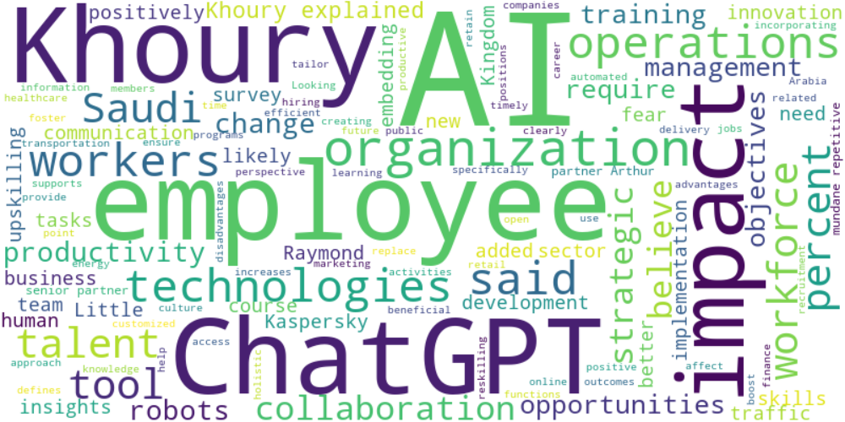

Top 10 words:

- AI: 35

- Khoury: 16

- ChatGPT: 12

- employees: 11

- impact: 9

- technologies: 6

- operations: 6

- said: 6

- workers: 6

- Saudi: 5

## Wordcloud for #fb5b89 Highlights

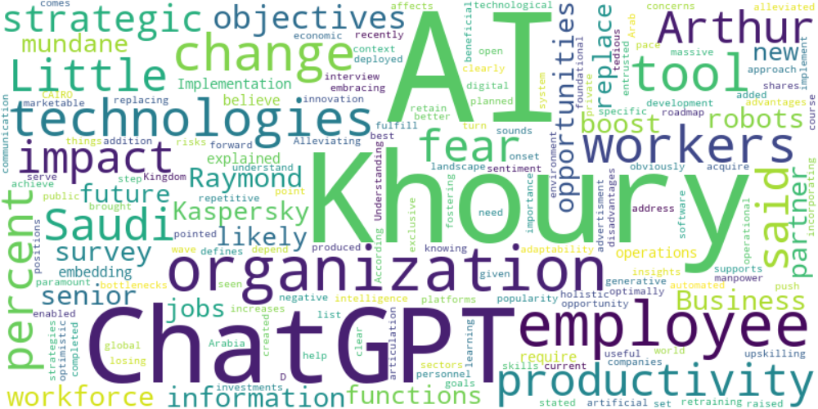

Top 10 words:

- AI: 14

- Khoury: 9

- ChatGPT: 6

- employees: 5

- technologies: 4

- workers: 4

- impact: 3

- Saudi: 3

- productivity: 3

- Arthur: 3

## Wordcloud for #f9cd59 Highlights

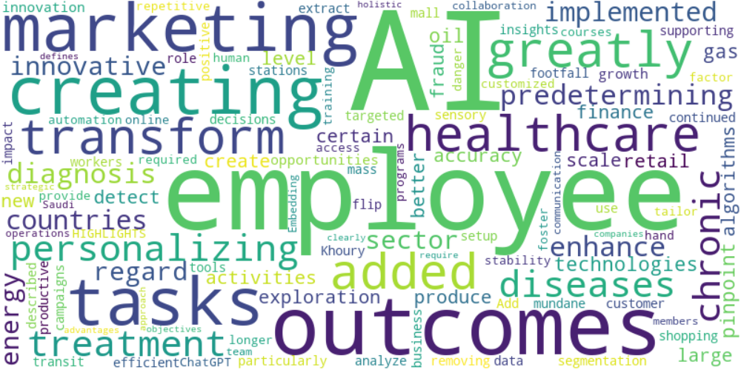

Top 10 words:

- AI: 7

- employees: 3

- outcomes: 2

- marketing: 2

- creating: 2

- tasks: 2

- added: 1

- greatly: 1

- transform: 1

- healthcare: 1

## Wordcloud for #c885da Highlights

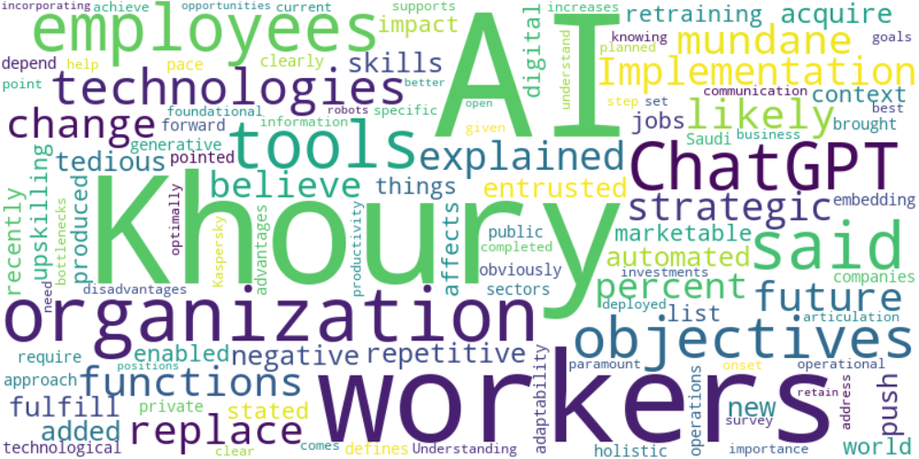

Top 10 words:

- AI: 8

- Khoury: 6

- workers: 4

- ChatGPT: 3

- said: 3

- tools: 3

- employees: 3

- objectives: 3

- organization: 3

- technologies: 3